**Appoinment BOOKING SYSTEM**

# Introduction

Appointment Booking System is designed to streamline the process of booking consultation sessions between university officers and students. The system allows officers to set their availability and assign subjects for different time slots, while students can request appointments based on officer availability and subject expertise.

# Problem/Impact/Successful Outcome

|  |  |  |
| --- | --- | --- |
| The Problem | The Impact | The Successful Outcome |
| Officers and students rely on email messages for appointment communication, and there is a lack of a proper centralized system to manage bookings and notifications. | This reliance on email may lead to missed or delayed appointments, communication errors, and lack of proper tracking, which reduces the effectiveness of student-officer consultations. | The implementation of a centralized booking platform reduces dependency on email, ensuring efficient and timely scheduling of sessions with automatic notifications, improving the overall experience for both officers and students. |

# Objectives

|  |  |  |  |
| --- | --- | --- | --- |
| ID | Business Objective | Business Owner | Business Importance |
| O01 | To create an accessible booking platform for officer availability. | University Admin | High |
| O02 | To enhance communication between students and officers by automating the booking process. | University Admin | High |
| O03 | To provide real-time updates for booking confirmations, cancellations, and reminders. | University Admin | High |

# Purpose Of Document

The Business Requirements Specification (BRS) aims to capture the requirements for the Appointment Booking System. It ensures that the business and functional needs are addressed systematically and that stakeholders have a clear understanding of the project's objectives and deliverables. Scope

|  |  |
| --- | --- |
| In Scope | Out Of Scope |
| Development of a web-based platform for booking appointments between officers and students. | Development of a dedicated mobile app for the system. |
| Real-time availability updates for officers, enabling students to book appointments based on specific subjects. | Advanced analytics for tracking officer-student interactions or session insights. |
| Automated email notifications and Outlook calendar invite integration for confirmed sessions. | Integration with external or non-University systems (e.g., third-party scheduling software). |
| Automated reminders for both officers and students regarding pending or upcoming appointments. | Real-time monitoring of student participation during scheduled sessions. |

# Definitions, Acronyms and Abbreviations

|  |  |
| --- | --- |
| Abbreviation/Acronym | Description |
| UI | User Interface |
| API | Application Programming Interface |

# Risks

|  |  |  |  |
| --- | --- | --- | --- |
| Ref | Risk | Detailed BRS Reference | Detailed Description |
| R01 | Delay in officer responses. | Functional Requirements | Delays in responding to booking requests may cause dissatisfaction among students. |
| R02 | System downtime. | Non-Functional Requirements | Technical issues like downtime could prevent students from booking sessions. |
| R03 | Data breaches. | Non-Functional Requirements | Unauthorized access could compromise sensitive information, such as officer availability and student booking details |

# Assumptions

|  |  |  |
| --- | --- | --- |
| Ref | Assumption | Detailed BRS Reference |
| A01 | Officers will actively update their availability in the system. | Functional Requirements |
| A02 | Students will use their institutional emails for booking and notifications. | Functional Requirements |
| A03 | System updates and bug fixes will ensure reliable operation. | Non- Functional Requirements |

# Issues

|  |  |  |
| --- | --- | --- |
| Ref | Issue | Detailed BRS Reference |
| I01 | Lack of student awareness about the booking system. | High-Level To-Be Requirements |
| I02 | Officers may forget to update their availability, leading to scheduling conflicts. | Functional Requirements |
| I04 | Some students may struggle with navigating the online booking platform without proper guidance. | Usability and Training Requirements |

# Dependencies

|  |  |  |
| --- | --- | --- |
| Ref | Dependency | Detailed BRS Reference |
| D01 | Availability of internet connectivity for officers and students. | Functional Requirements |
| D02 | System maintenance and support services for the booking platform. | Non-Functional Requirements |

# As Is Process

Currently, students manually contact officers via email or office visits to schedule consultations, resulting in delays and inefficiencies in managing officer availability.

# Context Diagram

# Process Overview Diagram

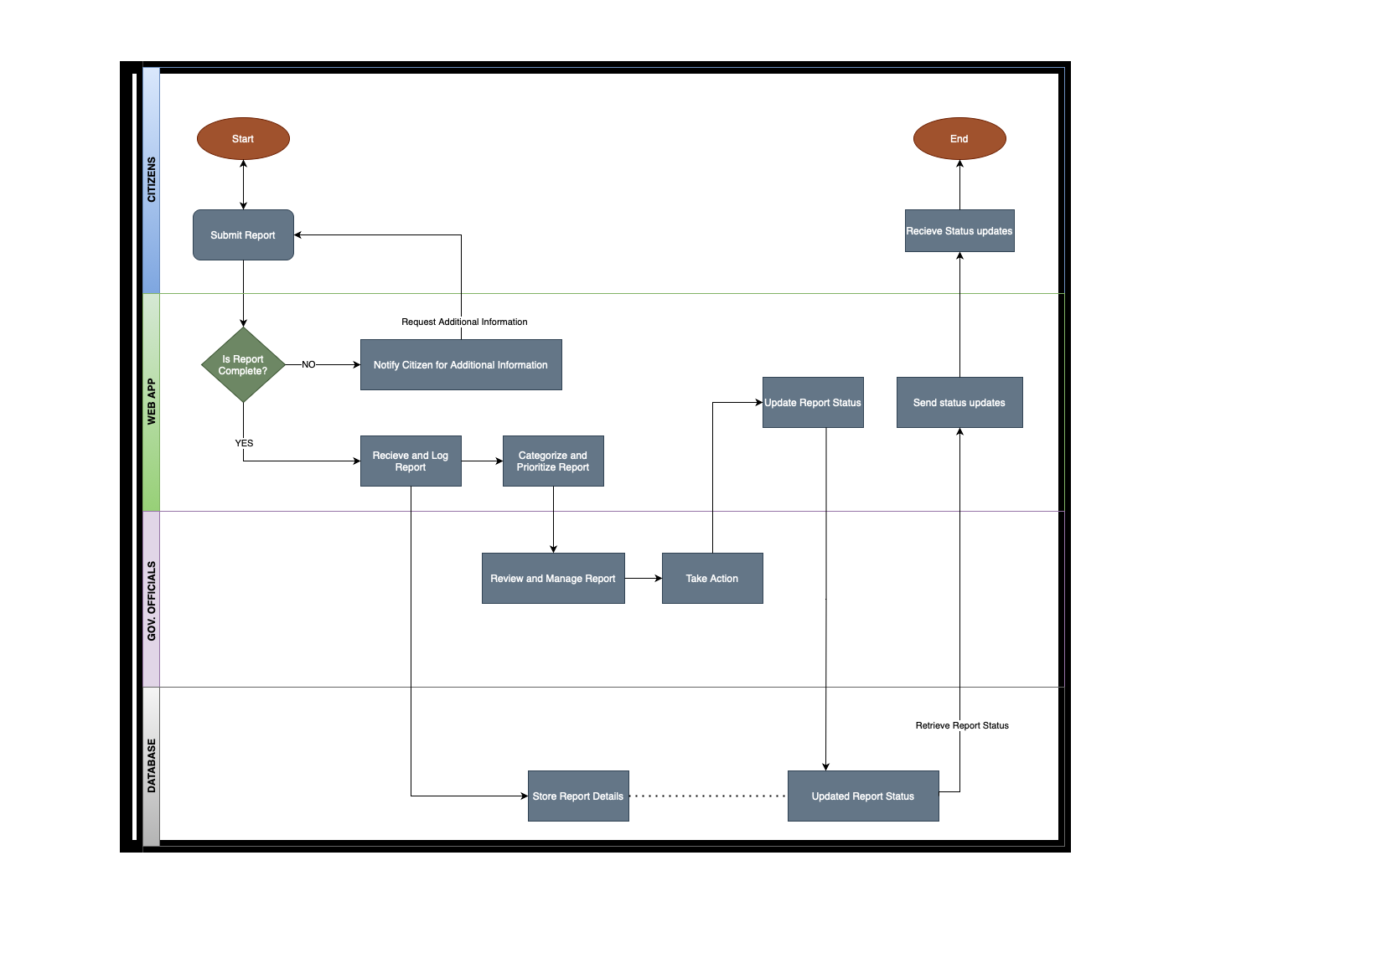

# High-Level To Be Business Requirements

The system will provide a streamlined platform for officers to manage their availability and for students to book sessions based on officer expertise and time slots. It includes email notifications and calendar integration to ensure both parties are well-informed of the scheduled appointments.

# User Personas

**Persona 1: John Anderson (Student)**

**Age**: 20  
**Occupation:** University Student (Third-year Computer Science)  
**Technology Use:** Regular user of web applications, smartphones, and university-provided systems.

**Objectives:**

* To easily book a time slot with university officers for academic or personal guidance.
* To select the right officer based on the subject of concern.
* To receive timely notifications for confirmed, pending, or denied bookings.

**Challenges:**

Struggles with finding available time slots for specific subjects due to limited officer availability.

Frustrated when emails or notifications are delayed or missed, leading to confusion over appointment status.

Prefers an intuitive, mobile-friendly system that is easy to navigate for scheduling appointments.

**Scenario:**  
John is seeking advice on an academic project and needs to meet an officer who specializes in his area of concern. He logs into the Booking System, selects a suitable officer, and requests an available time slot. After receiving an email confirmation and calendar invite, John attends the scheduled meeting and receives valuable feedback.

**Persona 2: Sarah Patel (Officer)**

**Age**: 38  
**Occupation**: University Officer (Counseling and Support Services)  
**Technology Use**: Proficient with administrative systems and regularly uses email for communications.

**Objectives**:

* To efficiently manage her availability by setting up time slots for student appointments.
* To respond promptly to student booking requests and provide alternate time suggestions when necessary.
* To receive reminders for pending or upcoming appointments.

**Challenges**:

* Managing a large number of student requests within limited available hours.
* Difficulty in communicating with students efficiently when appointments are missed or canceled without prior notice.
* Needs a well-organized dashboard to track her daily schedule and upcoming bookings.

**Scenario**:  
Sarah logs into the system to update her availability for the week. Throughout the day, she receives several booking requests from students. She accepts some requests and suggests alternate time slots for others. The system automatically sends confirmation emails and calendar invites to the students, keeping her schedule organized and manageable.

**Persona 3: Michael Smith (IT Administrator)**

**Age**: 30  
**Occupation**: University IT Support Specialist  
**Technology Use**: Expert-level user responsible for maintaining university software and systems.

**Objectives**:

* To ensure the Booking System operates smoothly with minimal downtime.
* To troubleshoot and resolve any technical issues reported by officers or students.
* To maintain system security, ensuring all data is properly handled and protected.

**Challenges**:

* Dealing with unexpected technical issues that may affect booking functionalities or notifications.
* Ensuring timely updates and maintenance without disrupting the user experience.
* Managing user access controls and safeguarding against unauthorized access.

**Scenario**:  
Michael receives a report from a student about a missing booking confirmation email. After investigating, he identifies a minor server issue and resolves it. He also makes sure all scheduled reminders are sent correctly and monitors the system for any additional issues. The system is back to normal operation, and the student receives their confirmation shortly after.

# Detailed Business/IT Requirements

## Functional Requirement

|  |  |  |  |  |  |  |  |
| --- | --- | --- | --- | --- | --- | --- | --- |
| **ID** | **Title** | **Requirements Description** | **Type** | **Priority** | **Status** | **Delivered By** | **Test ID** |
| FR001 | Officer Availability | Officers can set their availability and specify time slots for student appointments. | Application | Must Have | Proposed | Development | T001 |
| FR002 | Location Selection | Officers can choose whether the session is **online** or **offline**. | Application | Must Have | Proposed | Development | T002 |
| FR003 | Teams Meeting Link for Online | If an officer selects an **online** session, the system automatically sends a **Teams meeting link** via email to the students. | Integration | Must Have | Proposed | Development | T003 |
| FR004 | Location Details for Offline | If an officer selects an **offline** session, the system automatically sends the **location details** via email to the students. | Application | Must Have | Proposed | Development | T004 |
| FR005 | Multiple Students per Time Slot | The system allows **multiple students** to book the same time slot for a session with the officer (group sessions). | Application | Must Have | Proposed | Development | T005 |
| FR006 | Booking Notifications | Students receive confirmation emails with either the Teams meeting link or location details, depending on the session type. | Integration | Must Have | Proposed | Development | T006 |
| FR007 | Session Reminders | Automated reminders are sent to officers and students before the session (both online and offline), including relevant details. | Application | Should Have | Proposed | Development | T007 |

# Process Diagram

<Include a process flow diagram which links to the functional requirements above if necessary>

# Non-Functional Requirements

|  |  |  |  |  |  |  |  |  |
| --- | --- | --- | --- | --- | --- | --- | --- | --- |
| ID | Title | Requirements Description | Type (*) | MoSCoW Priority | Originator | Status (**) | Delivered By | Test ID |
| NFR001 | Security | The system must have secure login and data handling processes to ensure authorized access and data privacy compliance. | Security | Must Have | Stakeholder | Proposed | Development | T001 |
| NFR002 | Performance | The system should handle up to 500 concurrent users without performance degradation. | Performance | Should Have | Stakeholder | Proposed | Development | T002 |
| NFR003 | Usability | The interface should be intuitive and easy for officers and students to navigate, ensuring smooth user experience. | Usability | Must Have | Stakeholder | Proposed | Development | T003 |
| NFR004 | Availability | The system should be available 99.9% of the time, with maintenance scheduled during off-peak hours. | Availability | Must Have | Stakeholder | Proposed | Development | T004 |
| NFR005 | Scalability | The system should be scalable to support future growth in student and officer numbers, up to 1000 users. | Scalability | Should Have | Stakeholder | Proposed | Development | T005 |
| NFR006 | Email Delivery | The system must ensure timely and reliable delivery of emails for appointment confirmations and reminders. | Communication | Must Have | Stakeholder | Proposed | Development | T006 |

# Business Impact Assessment

|  |  |
| --- | --- |
| Lens | Key Impacts |
| **Process** | The new booking system will automate the scheduling process for both officers and students, reducing the need for manual intervention and follow-up. This can lead to faster appointment scheduling, better time management for officers, and more efficient handling of student requests. |
| **People** | Officers and students will require training to use the system effectively. The system will streamline the communication between students and officers, reducing workload and minimizing the potential for miscommunication. |
| **Students** | Students will have a more accessible and transparent way to book appointments with officers, improving the overall student experience and increasing satisfaction with university services. The system will offer real-time updates and eliminate reliance on manual emails. |
| **Financial** | Initial costs include system development, implementation, and training for officers and students. Over time, operational costs may decrease due to the system’s automation and reduced reliance on manual processes, resulting in better resource allocation. |
| **Data & MI** | Data governance will be enhanced through structured data collection from student bookings and officer availability, enabling better decision-making and analytics for university management. The system will track appointments, requests, and outcomes, providing valuable insights. |
| **Product & Proposition** | The implementation of the system could lead to additional digital solutions for student engagement and officer-student communication, expanding the university’s offerings in digital services for both students and staff. |
| **Supplier** | Any third-party suppliers providing email or calendar integration components (e.g., Microsoft Teams) must ensure compatibility and provide ongoing support during the integration phases. |
| **Management** | Management will need to oversee the transition to the new system, including any changes to officer workflows, new training requirements, and ensuring that the system is adopted effectively by both students and officers. |

# Costs

The estimated costs include platform development, server hosting, and integration of calendar invite services. Training costs for officers and students will also be considered.